HUME-Maize: A dynamic crop growth model for silage maize (Zea mays)

Katja Holzhauser^{a *}, Babette Wienforthª, Martin, Komainda^{b}, Antje Herrmann^{c}, Iris Zimmermann^{d}, Michaela Dippold^{e}, Sandra Spielvogel^{d}, Henning Kageª, Josephine Bukowieckiª
ª Institute of Crop Science and Plant Breeding, Agronomy and Crop Science, Kiel University, Hermann-Rodewald-Str.9, 24118 Kiel, Germany
^{b} Department of Crop Sciences, Grassland Science, Georg-August-University of Göttingen, Von-Siebold-Str. 8, 37075 Göttingen, Germany
^{c} Hessen Department of Agriculture Affairs, Schlossstraße 1, 36251 Bad Hersfeld, Germany
^{d} Institute of Plant Nutrition and Soil Science, Soil Science, Kiel University, Hermann-Rodewald_Str.2, 24118 Kiel, Germany
^{e} Department of Geoscience, Geo-Biosphere Interactions, University of Tübingen, Schnarrenbergstraße 94-96 72076 Tübingen, Germany
* Corresponding author.: holzhauser@pflanzenbau.uni-kiel.de (Katja Holzhauser)

Abstract
Modelling crop growth is crucial for agricultural research. Including detailed processes of plant growth and water uptake enable the analysis on effects of breeding progress on plant allometry, of crop sequences and soil textures on root growth and water uptake, thus enabling forecasts of potential crop yields under current and changing climate conditions. This study endeavors to establish a foundational framework for a dynamic growth model, specifically tailored for silage maize within European climate contexts, termed HUME-Maize. The model considers drought stress and focussed on the mid-early maturity group and sufficient nitrogen supply. Data from multi-annual field trials conducted under a huge gradient of climatic conditions and contrasting soil types served as basis for calibration and an independent model evaluation. Parameters of the model components development, dry matter production, partitioning, root growth, evapotranspiration and soil water balance were determined by linear regression or derived by literature research. Model performance in terms of dry matter production resulted in R² of 0.97 and 0.95 for calibration and evaluation datasets, respectively. Despite differing sowing dates, growth stages were simulated with high confidence during the whole season with RMSE of 8.83 d for calibration and 4.43 d evaluation datasets. The resultant HUME-Maize model emerges as a valuable tool for comprehending and predicting silage maize growth under European climate conditions. Furthermore, it serves as a foundation for future investigations, with potential expansions to include nitrogen limitations or differences in cultivar specific phenotypes.

Keywords: Zea mays L., crop growth model, yield prediction, dry matter partitioning, drought stress

Introduction
The modelling of crop growth stands as a pivotal effort in agricultural research, providing not only insights into the underlying processes of plant growth but also holding significant implications for optimizing crop yields and promote sustainable agricultural practices. Being able to assess potential yields for future scenarios, crop simulation models are important tools for forecasting food security and yield gaps under climate change conditions (Gavasso‐Rita et al., 2023). In the past decades, several crop growth models for wheat, rice and maize have been developed and tested globally (Basso et al., 2016).
For maize (Zea mays, L.), CERES-Maize (Jones and Kiniry, 1986) can be regarded as the origin of process orientated plant growth simulation. The model runs by weather data and is based on the approach that plant growth is dependent on the product of photosynthetic active radiation (PAR) and the light use efficiency (LUE). Further growth stages are separated into important physiological timepoints, such as silking or grain filling, but eventually depending on temperature. Later on, Jones et al. (2003) developed a more generic model called DSSAT, providing a user-friendly platform that enables farmers and researchers to analyse different scenarios and improve their decision-making in the field of agriculture. Yang et al. (2004) modified CERES-Maize with regard to cultivar-specific effects and recently improved root growth and water deficit responses to the model named HYBRID-Maize. As both models were developed in the United States, Australian researchers developed a growth model named APSIM adjusted to their respective site conditions (Keating et al., 2003). Nowadays, APSIM is used worldwide and is adaptable to various site conditions and crops (Brown et al., 2019).
However, these maize growth models were developed for the simulation of grain maize growth. Whereas in Northwest Europe, maize is mainly harvested as green maize or silage maize, hence earlier in the vegetation period (European Commission, 2023). Main European silage maize growing regions are situated in France and Germany (European Commission, 2023). Recently, Morel et al. (2020) reparametrized APSIM-Maize for silage maize and for higher latitudes in Northern Europe. Yet, their model distinctly underestimated biomass production. Morel et al. (2020) traced this back to missing adjustments to climatic conditions, especially concerning radiation uptake and day lengths, and concluded a large need for further data acquisition. However, it could be a more efficient approach to adapt an already well-performing crop model under Northern European conditions to silage maize. The crop growth and soil simulation model approach HUME (Kage and Stützel, 1999) was already successfully applied to model yield formation of winter wheat (Johnen et al., 2014; Ratjen et al., 2018) and of winter oilseed rape (Böttcher et al., 2020) under European conditions.
Therefore, the aim of this paper was the development of a dynamic growth model for silage maize suited for the climate conditions of the main European silage maize growing area. For this purpose, the model approach HUME was adjusted crop-specific and developed further. Data of multiannual field trials at different German sites formed the basis for calibration and independent evaluation. With the idea of conducting further studies advancing the resulting HUME-Maize model, this study focusses on growth conditions without any nitrogen limitations and on silage maize of one maturity group only.

Material and Methods

Datasets
The data basis comprises sets of field trials conducted across four distinct sites in Northern to Central Germany under temperate agro-climatic conditions over four consecutive years (Table 1; data set 1-14), focusing on mid-early silage maize cultivars. The trials had a randomised block design (4 replications) ensuring adequate N fertilization. Geographical positioning, soil texture, year of study, and sowing dates varied across trial sites, as detailed in Table 1. Meteorological data was retrieved of the nearest DWD weather station (Deutscher Wetterdienst, 2023) exhibiting notable discrepancies between sites and across different years (Table 1). In order to facilitate an unbiased assessment, the data was divided into a calibration dataset and an evaluation dataset. Both datasets encompass field observations from two distinct years and at least two sites, each exhibiting significant variations in weather conditions.

Calibration datasets
All model parameters for above-ground plant growth were calibrated by dataset 1-6 (Table 1). The field trials for this were conducted at two sites (Hohenschulen and Karkendam, experimental farms of Kiel University) in Northern Germany in 2007 and 2008 (Table 1) as part of a research project focusing on nitrogen use efficiency in biogas production systems. The experimental farm Hohenschulen is located on a sandy loam soil (Luvisol) and the soil at Karkendam is sand (Gleyic Podzol). Both study sites are influenced by the maritime climate of the Baltic Sea. Weather conditions during the observed growing seasons are shown in Table 1. From the different trial treatments, plots of two different crop rotations and therefore different sowing dates were chosen (Table 1). From each crop rotation, two treatments of highest nitrogen levels were used for model calibration (240, 300 kg N ha⁻¹) in order to exclude N limitation. Within this study, no cultivar-specific differences were considered. The grown cultivar was KWS Ronaldinio from a mid-early maturity group.
Calibration of the root growth parameters was done by data of a research project examining the root growth of maize after different winter cover crops (dataset 8 and 12). The trials took place at the above described experimental farm Hohenschulen during summer 2021 and 2022. However, above ground measurements of dataset 8 and 12 were used for model evaluation.

Evaluation datasets
The model was evaluated with data of set 7-14. All field trials were conducted in 2021 and 2022. The trials providing dataset 7, 8, 11 and 12 were conducted at the experimental farm Hohenschulen (site A), but differed in the sowing date and the year of cultivation. The field trials for dataset 9 and 13 were located in the Northwest of Germany at the experimental farm Wehnen of the Agricultural Chamber of Lower Saxony and coordinated by the University of Göttingen (site C). Dataset 10 and 14 were compiled by field trials at Bad Hersfeld in Central Germany, managed by the Hessen department of agriculture (site D). In addition to climatic differences, soil types of location C and D were sand and sandy silt, respectively. The field trials of datasets 7, 9, 10, 11, 13 and 14 were conducted within a research project focussing on the nitrogen use efficiency of maize (Table 1). The N levels chosen for the present study were 180, 240 and 300 kg N ha⁻¹, to ensure sufficient N supply. Mid-early maturity groups were selected for evaluation datasets as well (KWS Gunnario: 7,9,10,11,13,14; KWS Stefano: 8, 12).

Data sampling
Aboveground biomass was consistently measured sequentially over several dates of the growing season by means of destructive manual sampling. Therefore, at least 10 plants per plot were harvested and weighted. In order to assign the dry matter weights to a specific area, length of harvested maize rows were determined to form a parallelogram and consequently its area. An aliquot of the harvested plants was fractionated into the organs, leaf, stem and cob (DM_{leaf}, DM_{stem}, DM_{cob}). As small generative organs, husk and panicle were assigned to cob dry matter. For all organs, DM was determined and summarized to DM_{shoot}. For each sampling, GAI was determined by scanning the leaves (LAI) and stems (SAI) using the LAI-3100 (LI-COR, Inc., Lincoln, NE, USA).
In the field trials used for evaluation, GAI was additionally monitored by drone-based multispectral measurements with a SequoiaTM camera (Parrot Sequoia, Parrot Drones SAS, 143 Paris, France) and a corresponding GAI calibration for silage maize (Bukowiecki et al., 2024), Crop height, BBCH (Lancashire et al. 1991) and number of leaves (only for 2008) were determined frequently during the growing season.
Root growth was measured in the field trials providing dataset 8 and 12 (Table 1). In both trial years root length (RL) and root length density (RLD) were monitored to a soil depth of 120 cm, either by soil pits or by soil cores. Soil cores were sampled at silking and grain filling and divided into 10 cm sections. After washing the samples, extracted roots were scanned using the Epson Perfection V850 Pro. The scans were analysed using RhizoVision Explorer v2.0.3 (Seethepalli et al., 2021). Rooting depth (zr) was investigated at four timepoints during the growing period of 2022 (dataset 12) measuring the deepest visible root in the soil pit.
Table 1 Datasets used for calibration and evaluation. The datasets differ in their location (Site A: Hohenschulen, Site B: Karkendam, Site C: Wehnen, Site D: Bad Hersfeld), soil type, trial year and sowing dates. Temperature is averaged and precipitation is summed up over the growing season (sowing till harvest date).
Data use |  |  | Dataset | Site | Geographical position | Soil type | Trial year | Sowing date | Temperature [°C] | Precipitation [mm]
Calibration |  | Evaluation shooth growth
Shoot growth | Root growth
X |  |  | 1 | A | 54.18°N, 9.58°E | sandy loam | 2007 | 2007/04/19 | 14.8 | 496.5
X |  |  | 2 | A | 54.18°N, 9.58°E | sandy loam | 2007 | 2007/05/15 | 15.4 | 452.4
X |  |  | 3 | B | 53.55°N, 9.56°E | sand | 2007 | 2007/04/20 | 15.1 | 520.7
X |  |  | 4 | A | 54.18°N, 9.58°E | sandy loam | 2008 | 2008/04/24 | 14.5 | 370.6
X |  |  | 5 | A | 54.18°N, 9.58°E | sandy loam | 2008 | 2008/04/30 | 14.6 | 357.9
X |  |  | 6 | B | 53.55°N, 9.56°E | sand | 2008 | 2008/04/28 | 15.1 | 371.4
 |  | X | 7 | A | 54.18°N, 9.58°E | sandy loam | 2021 | 2021/04/28 | 15.4 | 461.8
 | X | X | 8 | A | 54.18°N, 9.58°E | sandy loam | 2021 | 2021/05/20 | 16.0 | 389.7
 |  | X | 9 | C | 51.49°N, 9.93°E | sand | 2021 | 2021/05/01 | 15.5 | 524.3
 |  | X | 10 | D | 51.59°N, 9.85°E | sandy silt | 2021 | 2021/05/31 | 15.6 | 322.7
 |  | X | 11 | A | 54.18°N, 9.58°E | sandy loam | 2022 | 2022/04/28 | 16.2 | 238.7
 | X | X | 12 | A | 54.18°N, 9.58°E | sandy loam | 2022 | 2022/04/29 | 15.7 | 273.5
 |  | X | 13 | C | 51.49°N, 9.93°E | sand | 2022 | 2022/05/02 | 17.3 | 182.5
 |  | X | 14 | D | 51.59°N, 9.85°E | sandy silt | 2022 | 2022/05/09 | 18.4 | 132.5

The model
The silage maize crop growth model is built in the modelling environment HUME (Kage and Stützel, 1999). It is an object-orientated component library, based on the software development technology Delphi® /C++ Builder®. Within HUME, there are several components depicting different parts of the soil-water-atmosphere-plant continuum. These can be linked to a main component and fitted crop-specifically to model crop growth of winter wheat (Johnen et al., 2014; Neukam et al., 2016) or winter oilseed rape (Böttcher et al., 2020). The components of this library used for the maize crop growth model are evapotranspiration, dry matter production, dry matter partitioning, root growth and soil water balance described in the following chapters. All components are linked to a main model component, which provides the simulation and a basic statistical analysis. A component includes variables, state variables, parameters and external variables. The latter describes variables, which are either exchanged between the components or input variables, to start the model (e.g. temperature, global radiation).
Crop-specific modifications of components and crop-specific fits of parameters were either derived by chosen scientific studies or computed by linear regression based on the calibration data (Table 1). A table of these model parameters, their value, description and source can be found in Appendix B (Table B 1). Model performance was tested with regard to above-ground shoot growth and the partitioning to the organs, as well as the plant development. Therefore, root mean squared errors (RMSE), intercepts, slope sand R² between the measured vs. simulated regressions were calculated for the calibration and evaluation. Model equations (E) are listed in Appendix A. Parameter calibration and model evaluation was carried out using the software R (R Core Team, 2023). The performance was assessed with slope and intercept of the regression between measured and simulated data, R² and root mean square error (RMSE).

2.2.1. Development
Maize development is regulated by the effective temperature (T_{eff}) – derived by the positive difference of daily mean temperature and a defined base temperature (T₁) of 6°C in agreement with Pagès and Pellerin (1994) and Bonhomme et al. (1994)). Furthermore, the development process is separated into five stages further named XStage, following HYBRID-Maize, based on the approach of Yang et al. (2016). The XStages represent the development stages emergence, tassel initiation, silking, effective grain filling and maturity (Figure 1). Development rates between sowing and emergence (DevRateS0), emergence and tassel initiation (DevRateS1), tassel initiation and silking (DevRateS2), silking and grain filling (DevRateS3) are calculated as simple ratio of T_{eff} and the temperature sum (GDD) between the respective XStages (E1-E4). Compared to the approach of Yang et al. (2016), an additional GDD is introduced from emergence till silking (GDD_{silk}) to calculate the development rate from grain filling until maturity (DevRateS4, E5).The GDDs are defined cultivar specific parameters assigned according to the assumptions of Bignon (1990) for a mid-early cultivar at a soil with medium warming dynamics, harvested at the dough stage, which is the harvest date of whole crop silage maize with a typical DM content of 35%.
Growth of leaf number is calculated according to the approach of HYBRID- and CERES-Maize (Jones and Kiniry, 1986; Yang et al., 2016). Thereby, leaf growth is the ratio between T_{eff} and the parameter phyllochron (phy, E6). For the early growth period in which the plant has less than five leaves (< BBCH15), growth rate is assumed to be higher. Therefore, a factor (f_{phy}) is reducing phy (E7). However, in the field trials, growth stages were recorded according to the BBCH scale of Lancashire et al. (1991), hence, were converted into XStages for model evaluation (Figure 1).
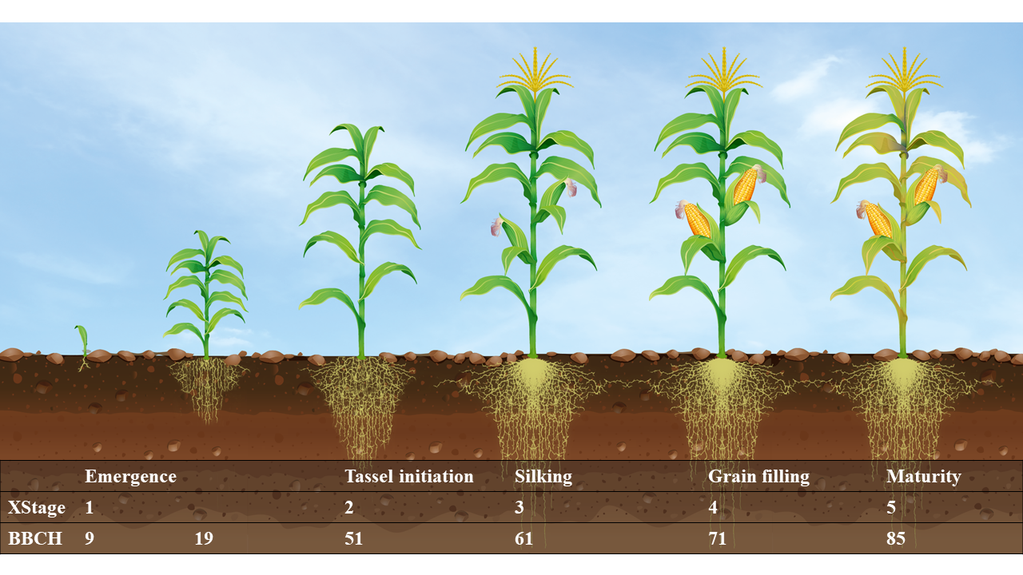
Figure 1 The XStages 1-5 represent the development stages emergence, tassel initiation, silking, effective grain filling and maturity. XStages can be converted to respected values of BBCH scale (Lancashire et al., 1991)

Dry matter production
Total dry matter production (DM_{tot}) is initialised at emergence by DM_{ini}, which is the weight of the seed (DM_{seed}) corrected by the weight fraction of the hypocotyl (f_{hypo}) and the loss due to transformation and translocation processes (f_{trans}, E8). The DM_{ini} decreases constantly after sowing (E18). The DM_{seed} is always subtracted from total dry matter production (DM_{tot}, E9).
Within season, dry matter production is driven by absorbed photosynthetic radiation (Q) and potential light use efficiency (LUE). Potential LUE is reduced to actual LUE by a factor for photosynthetic activity (f_{T}) and a factor for soil water deficit (f_{SWDF}, E10-E13), introducing drought stress into the model. Q corresponds to the photosynthetic active radiation (PAR) which is commonly known as half of global radiation (GR, Szeicz, 1974), reduced by the radiation reflected by the canopy. It is calculated by the extinction coefficient k_{PAR} and the GAI according to the Beer-Lambert law (Monsi, 1953, E11). Therefore, GAI is provided by the dry matter partitioning component as external value to the dry matter production component.
Potential LUE was optimised by the model-internal Levenberg-Marquard algorithm to 3.6 g MJ⁻¹, remaining constant during the growing season. k_{PAR} is also assumed to be constant. f_{T} ranges from 0 to 1 and is calculated with a trapezoidal function (Porter and Gawith, 1999). f_{SWDF} is calculated within the model as the ratio of actual transpiration to potential transpiration (E13).

Dry matter partitioning
In the first step, the dry matter partitioning component apportions the daily produced DM_{tot} (in the dry matter production component) between shoot dry matter (DM_{shoot}) and root dry matter (DM_{root}, E14, E15). Thereby, the increase of DM_{root} through the season is determined by the allocation coefficient (AC_{root}), calculated according to Yang et al. (2016), including a upper limit of root growth shortly after silking (DS_{stop}, E16, E17). DM_{shoot} is further distributed between leaf dry matter (DM_{leaf}), stem dry matter (DM_{stem}) and cob dry matter (DM_{cob}, E19) by dry matter allocation factors (E30): f_{leaf} describes the allocation to the leaves and f_{cob} to the cob (E21, E23).
f_{leaf} is the ratio of DM_{leaf} to DM_{shoot} increase between two sampling dates. f_{leaf} is assumed to increase linearly across the XStages starting at emergence with increasing XStages, described by the regression parameters f_{leafslope} and f_{leaf0} (E22, Figure 2 A). Due to translocation processes from leaf to stem, DM_{leaf} is assumed to decrease after silking (XStage3) or if the maximum GAI (GAI_{max}) has been reached. This decay is described through a f_{leaf} derived from a decreasing power function with two parameters (decay_{a}, decay_{b}, E22, Figure 2 B). f_{cob} is calculated as the ratio of DM_{cob} increase to the sum of DM_{cob} and DM_{stem} increase between two sampling dates (E24, Figure 2 C). If f_{cob} exceeds 1, dry matter is translocated from stem to cobs. As soon as DM_{stem} accounts for less than 24.8% (f_{stemmin}) of the DM_{shoot}, f_{cob} is set to 1 (E24). f_{stemmin} is the calculated average dry matter remaining in the stem at harvest. In a last step, stem growth rate can be derived by the combination of f_{leaf} and f_{cob} (E25).
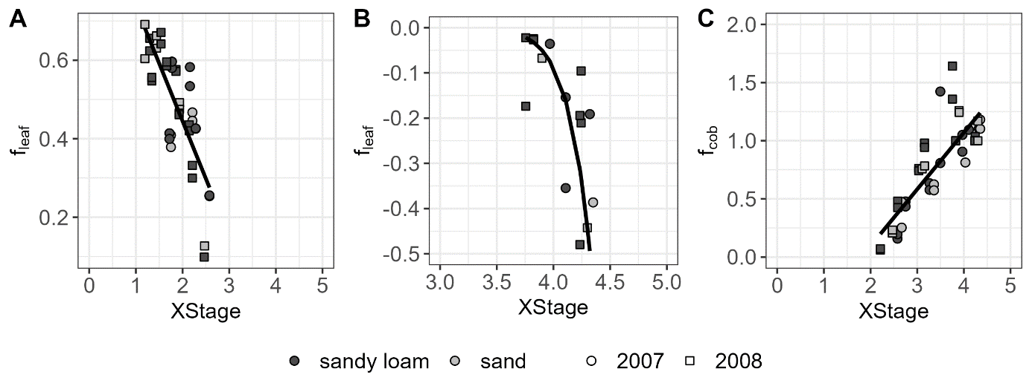
Figure 2 Calibration of the partitioning variables f_{leaf} and f_{cob} describing the dry matter growth rate of leaves and stems, by generating regressions to XStages. Depicted are the different soil types (sandy loam, sand) and trial years (2007, 2008). A: f_{leaf} is described by the parameters f_{leafslope} and f_{leaf0} until LAI_{max} is reached (f_{leaf}=f_{leaf0}+f_{leafslope}*XStage, f_{leaf0}= 1.032, f_{leafslope}= -0.293); B: For XStage>3 leaf decay due to translocation processes is described by a power function regression of f_{leaf} and XStages (f_{leaf}=decay_{a}*XStage^{decayb}; decay_{a}= -3.232 * 10⁻¹⁵, decay_{b}= 22.32); C: f_{cob} is decribed by a linear regression utilising the parameters f_{cob0} and f_{cobslope} (f_{cob}=f_{cob0}+f_{cobslope}*XStage; f_{cob0}= -1.095, f_{cobslope}= 0.5687)
GAI expansion and its growth rate is calculated as the sum of its compartments (LAI, SAI, E26) and their growth rates (E27), respectively. Growth rate of LAI is the product of the specific leaf area SLA and DM_{leaf} (E28, E32). Thereby, SLA is assumed to be the negative exponential function of LAI (E30, Figure 3 A). The functions were fitted with the calibration datasets and slopes, exponents, upper and lower limits were set as model parameters (Table B 1). The same applies for SAI and specific stem area (SSA, E29, E31, E33, Figure 3 B). The proportion of senescent leaf area is depicted by the factor f_{sen}, increasing exponentially from the time of silking (XStage3, E34, E35). Parameters for f_{sen} computation are sen_{a}, sen_{b} (E35). Thereby, it is assumed, that the ratio of the measured GAI values towards the highest measured GAI is the proportion of senescent leaf area.
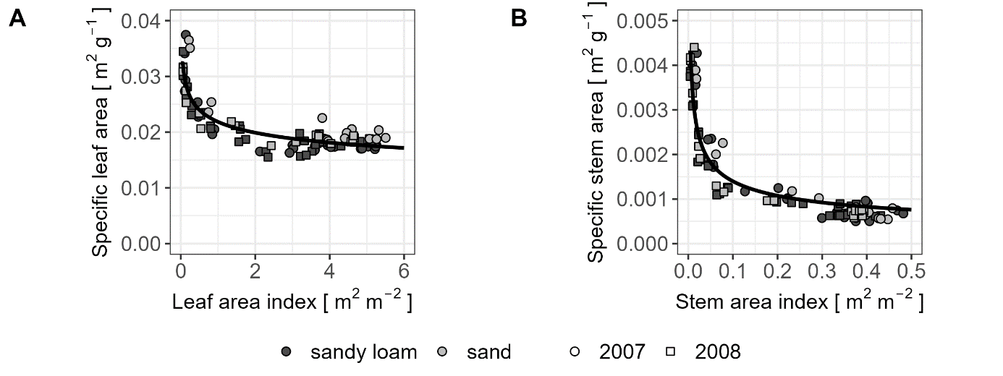
Figure 3: Calibration of model parameters for A: specific leaf area (SLA) and B: specific stem area (SSA), assuming, that both, SLA and SSA are decreasing with increasing leaf area index (LAI) and stem area index (SAI), respectively. SLA and SSA are restricted by an upper and a lower limit. Depicted are the different soil types (sandy loam, sand) and trial years (2007, 2008).
Plant height was derived from DM_{shoot}, using a quadratic function (E36) with the model parameters height_{a}, height_{b} and height_{c} (Table B 1).

Evapotranspiration
Required input for this component are weather data; daily mean temperature, global radiation (GR), windspeed, precipitation and vapour pressure deficit (VPD). Necessary external variables are provided by the dry matter partitioning component (GAI, crop height) and by the dry matter production component (k_{PAR}).
Potential evapotranspiration (ET_{pot}) is calculated by the Pennman-Monteith equation (Monteith, 1973), being the sum of potential transpiration (T_{pot}), potential evaporation (E_{pot}) and interception (I) (E39). E_{pot} is calculated by the fraction of radiation, which is transmitted, calculated with an exponential function of GAI and k_{PAR}. Calculation of interception is described in Kage et al. (2003). T_{pot} is derived as the difference of E_{pot} and I from ET_{pot}.

Soil water dynamics
Vertical soil water movement is calculated based on Richards equation (E40) along an diffusion approach, more detailed by Johnen et al. (2014), Neukam et al. (2016) and Böttcher et al. (2020). Soil textures are set site-specific and were determined in the field for each of four defined soil layers. The van Genuchten (1980) parameters following Mualem (1976) parameterisation (α,ϴs, ϴr, n) and saturated hydraulic conductivity Ks are derived from soil textures. To each soil layer, a sink term S[i] considering the water uptake by plants, is calculated by splitting T_{pot} (as external variable from the evapotranspiration component) across the four soil layers (E41). The distribution of T_{pot} is oriented on the prevailing root length of each soil layer (i). A parameter for root competition (CompF) is added, to explain reduced water uptake due to root competition (Ehlers et al., 1991; Kage et al., 2003). Soil water potential may limit the water uptake as well, if it exceeds the critical soil water potential (ψ_{crit}). Therefore, n reduction factor f_{sinkred} is included when estimating S[i], following the assumptions of Feddes (1980) and Belmans et al. (1983) (E42). Actual transpiration (T_{act}) is the sum of the soil layers sink terms (E43). Actual evaporation (E_{act}) is determined by reducing E_{pot} when the soil water potential in the top soil layer (ψ_{arr[1]}) falls below a critical threshold (ψ_{critevap}, E44, E45).To ensure an adequate representation of starting values, model was already started at the first of November of the previous year, respectively.

Root growth
The root growth component was introduced first by Kage et al. (2000) for cauliflower. Hence, all components were refitted for silage maize. As a function of DM_{root} and specific root length (SRL, Figure 4 C), root length (RL_{tot}) increases linear until maximum root depth (zr_{max}) or until DS_{stop} is reached (E46). DS_{stop} was introduced in the dry matter partitioning component and zr_{max} is a site-specific model parameter for the maximum rooting depth. Root depth growth starts with sowing depth (zr₀) and proceeds in a linear manner with a temperature dependent fitted parameter (k_{zr}, E47, Figure 4 A).
The exponential decrease of root length density with soil depth, depicting the vertical root distribution, is calculated with the coefficients kr, and RLD₀ (E48, Figure 4 B). RLD₀ is the RLD at zr = 0. kr is the fractional decrease with increasing soil depth z, determined by ratio between RLD_{zr} and RLD₀ (E49). To avoid iterative steps, the ratio is set as a fix parameter r_{RLD} (Table B 1).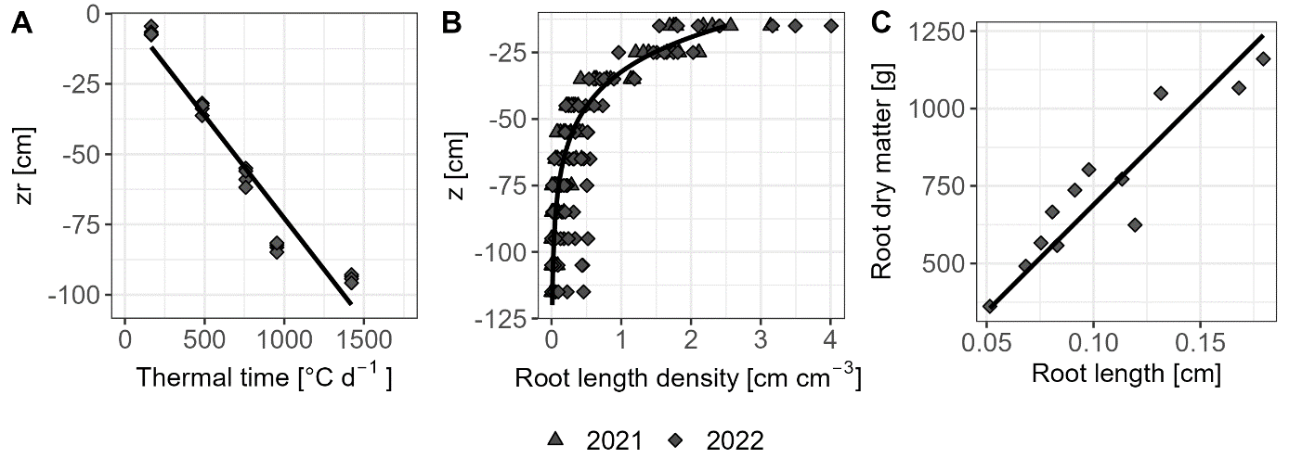
Figure 4 A: Root depth growth. Linear relation of root depth z to thermal time (dzr/dt = k_{zr}*T_{eff}, k_{zr}=0.703). B: Vertical root growth is described by an exponential function over soil depth z (RLD=RLD₀*e^{kr*zr}). C: Specific root length (SRL) depicted as the regression between root dry matter [g m⁻²] (DM_{root}) and root length (RL).

Results

Parameterisation
For the final model, 20 silage maize-specific parameters for aboveground plant growth and three parameters for root growth were fitted (Appendix B – List of model parameters). Potential LUE was optimised by the model intern Levenberg-Marquard algorithm, as described in model description. Parameters for the plant development, phy, and soil water dynamic components were derived from literature. A detailed list of all parameters containing their description, value and source can be found in Appendix B (Table B 1).

Development
Plant development describing XStages, translated to BBCH (Lancashire et al., 1991) was simulated sufficiently with R² of 0.93 and 0.98 in calibration and evaluation (Table 2), respectively. Variations due to different sowing dates, geographical position and soil types were well estimated (Figure 5). Inaccuracies occurred during BBCH 50 and 65, as the period of tassel initiation to silking may be difficult to quantify in the field.
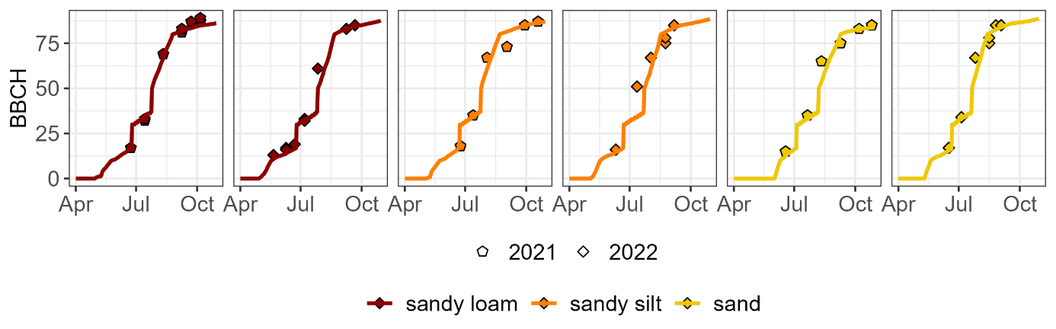
Figure 5 Model simulation of BBCH development stages (line) and measured BBCH of the evaluation datasets (point) over the vegetation period of maize. Depicted are evaluation datasets of 7, 11 (site A), 9, 13 (site C) and 10, 14 (site D) with their individual soil types starting at different sowing dates.

Dry matter production
With the calibration dataset, a strong fit was achieved for whole-season DM_{shoot} (R² = 0.97, Table 2) including measurement data of the whole season (n=83). The productivity on sandy loam sites was underestimated in 2008 and overestimated in 2007. However, predictions for the sandy site were accurate for both calibration years (Figure 6, A). In the evaluation, prediction accuracy of DM_{shoot} was still high with R² of 0.95 and a RMSE of 239.28 g m⁻² (Table 2). In 2021, high yields harvested at both sandy loam and sandy sites were underestimated by the model. Due to severe drought stress at the sandy and sandy silt site in 2022, harvest was conducted one month earlier (2022/09/06 and 2022/09/02, respectively), explaining the low yields (Figure 6, B).
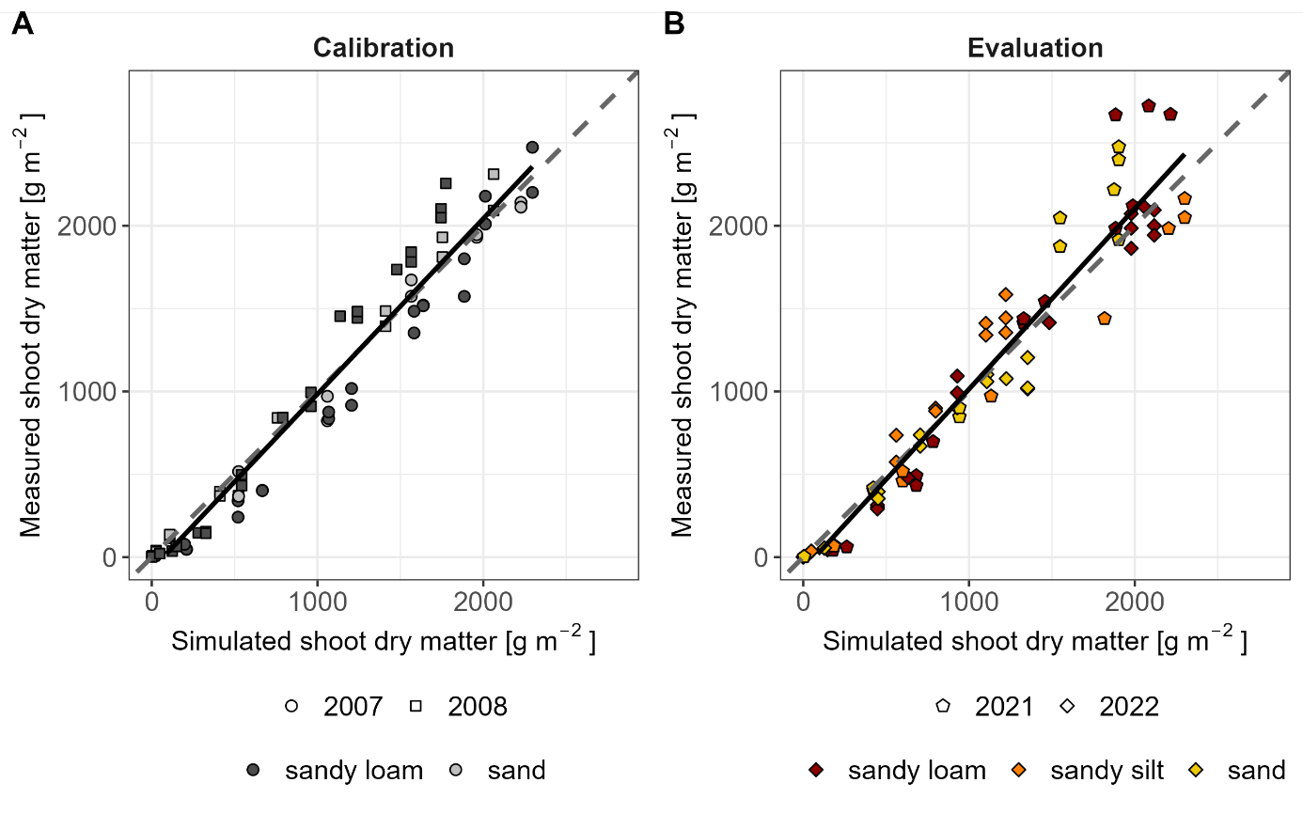
Figure 6 Dry matter estimation in calibration (grey) and evaluation (colourful) exhibit by simulated shoot dry matter [g m⁻²] against measured data of the evaluation datasets (7-12). Dashed line is the 1:1 line. Solid line is the regression between measured and simulated shoot dry matter [g m⁻²].

Dry matter partitioning
Partitioning into leaves, stems and cobs was well calibrated with R² of 0.82, 0.92 and 0.83, respectively, and regression slopes close to 1 (Table 2). However, simulating dry matter partitioning of evaluation datasets led to inaccuracies caused by over- and underestimation for DM_{leaf} and DM_{stem} (slopes: 0.83 and 1.65), followed by high RMSE’s of 78.21 g m⁻² and 217.9 g m⁻², respectively. Nevertheless, evaluation of DM_{cob} outperformed calibration with a slope of 0.98 and a R² of 0.91.
The GAI simulation depicted measurements well within the calibration (Table 2; R² = 0.73, slope = 0.92, RMSE = 1.08). Accuracy for its compartments LAI and SAI was even higher with RMSE’s of 0.98 and 0.05, respectively. Since LAI and SAI of evaluation datasets were calculated based on the imprecise simulated dry matter partitioning, the deviation continued for evaluation with R² of 0.50 and 0.56, respectively. However, the slopes for both compartments were high, with a slight overestimation (0.85 and 0.94). GAI, as the sum of LAI and SAI, achieved a reasonable fit with a slope of 0.85, an intercept of 0.87 and a R² of 0.63, indicating a moderate level of explained variability (n=212).
Crop height was simulated with a low RMSE of 0.24 m and an overestimation of high values (slope = 0.88). Evaluation datasets were predicted well (R²=0.97) although the base is a small n of 19.
Table 2 Results of model evaluation and calibration (in brackets) for development (BBCH), aboveground dry matter production (DM_{shoot}), dry matter partitioning into plant organs and the derived green area indices (DM_{leaf}, DM_{stem}, DM_{cob}, GAI, LAI, SAI) and of crop height. Performance was assessed with slope and intercept of the regression between measured and simulated data, R² and root mean square error (RMSE). n is the number of measurements.
Parameter | Unit | Slope | Intercept | R² | n | RMSE
BBCH | [d] | 0.99 (0.94) | 2.13 (7.66) | 0.98 (0.93) | 51 (183) | 4.28 (8.83)
DM_{shoot} | [g m⁻²] | 1.14 (1.08) | -102.91 (-73.91) | 0.95 (0.97) | 63 (83) | 239.28 (157.41)
DM_{leaf} | [g m⁻²] | 0.83 (0.89) | 27.17 (-5.70) | 0.44 (0.82) | 33 (83) | 78.21 (53.94)
DM_{stem} | [g m⁻²] | 1.65 (1.00) | -105.75 (-31.30) | 0.83 (0.92) | 34 (83) | 217.9 (85.04)
DM_{cob} | [g m⁻²] | 0.98 (1.04) | -41.47 (61.81) | 0.91 (0.83) | 22 (43) | 173.61 (206.07)
GAI | [-] | 0.85 (0.92) | 0.5 (0.08) | 0.63 (0.73) | 212 (81) | 1.18 (1.08)
LAI | [-] | 0.85 (0.90) | 0.12 (-0.11) | 0.5 (0.8) | 30 (81) | 1.27 (0.98)
SAI | [-] | 0.94 (0.92) | 0.03 (-0.01) | 0.56 (0.92) | 30 (81) | 0.1 (0.05)
Crop height | [m] | 1.39 (0.88) | -0.51 (-0.20) | 0.97 (0.96) | 19 (111) | 0.43 (0.24)

Evapotranspiration and soil water dynamics
At the time of sowing, soil was water-saturated at all study sites and years. During the season, the model depicted strong variations in the soil water balance. In 2021 on the sandy silt site and in 2021 and 2022 on the sandy loam site, optimal water availability was modelled (Figure 7). In 2007 and in 2021 on the sandy site, drought stress occurred only briefly in mid-June. A strong restriction of growth due to drought stress in 2022, particularly in sandy and sandy silt locations, as well as in 2008, in sandy loam and sandy areas (Figure 7). For example, the average f_{SWDF} on the sandy site in 2022 was 0.66, meaning that the potential LUE was reduced by one third.
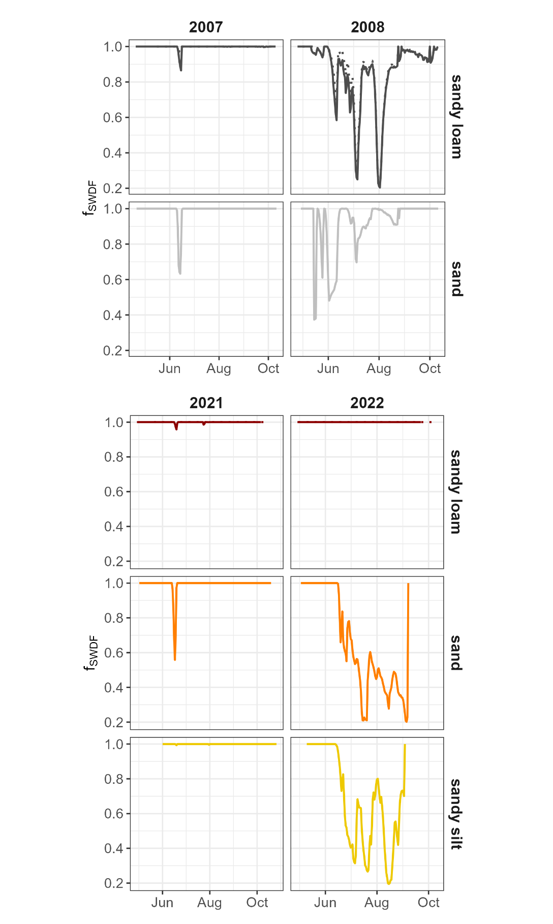
Figure 7 Soil water deficit factor (f_{SWDF}) as the ratio of actual and potential transpiration during the vegetation period, introducing drought stress to the model. Depicted is the f_{SWDF} for all datasets (calibration: grey; evaluation: colourful), arranged in trial years (columns) and soil types (rows). Start and end of line represent sowing and harvest date, each. Sandy loam site (site A) comprise each two datasets (Table 1) with differing sowing dates in each year. If their f_{SWDF} do not match, the dataset with the delayed sowing date is displayed by a dotted line.

Discussion
The target of this study was the development of a fundamental structure of a dynamic growth modelling for silage maize under the climate conditions of its European main growing area. The model was parameterised for growth conditions without nitrogen limitations. The fitted parameters can be regarded as first HUME-Maize-driven insights in silage maize growth. The requirements were, establishment of an easy adjustable model providing already reasonable results for different year/site-combinations within Germany.

Development
The development component is based on the assumptions of HYBRID-Maize (Yang et al., 2004). However, the growth conditions between Northern America (environment in which HYBRID-Maize was developed) and Europe differ. Furthermore, HYBRID-Maize focusses on grain maize whereas whole-crop silage maize is already harvested green and breaded with regard to shorter growing seasons. In consequence, several parameters in the development module of HUME-Maize had to be adjusted. The base temperature (T₁) was decreased from 8 °C respectively 10 °C (Jones and Kiniry, 1986; Yang et al., 2016) to 6°C following European studies on maize physiology (Bonhomme et al., 1994; Pagès and Pellerin, 1994). Alterations in the base temperature not only impact the effective temperature but also influence all GDD’s and consequently affecting the timing of XStages. All GDD’s to calculate the XStages were derived from the results of (Bignon, 1990) for mid-early cultivars. As the study focusses on silage maize, XStage5, describing the dough stage where whole crop silage maize is usually harvested, was selected at a dry matter content of 35 %. Measured and modelled BBCH growth stages correlate well in calibration (R² = 0.93, Table 2) and evaluation (R²: 0.98, Table 2, Figure 5). The R² for BBCH estimations are distinctly higher than those obtained by Morel et al. (2020) refitting APSIM for silage maize growth under North European conditions (R²: 0.81). As Bignon (1990) provided also GDDs for early- and late -cultivars, extending the model for further maturity groups should be feasible.
Additionally, the parameter phy, describing the phyllochron [°Cd], has been recalculated, experiencing an increase from 38.9 °Cd in Yang et al. (2016) to 50.8 °Cd (Table B 1). The results are corroborated by the study conducted by Dos Santos et al. (2022), which determined an average phyllochron of 51.5 °Cd by linear regression method. However, Dos Santos et al. (2022) suggest a bilinear relation for leaf number simulation, receiving an improvement of model efficiency by 3%.

Dry matter production
Similar to CERES-Maize, total dry matter production in HUME-Maize is driven by radiation uptake, for which potential LUE was set to a constant value of 3.6 g MJ PAR⁻¹. This value differs strongly from the proposal of 4.33 g MJ PAR⁻¹ by Kiniry et al. (1997) for grain maize. This can be traced back to the lower sowing density in grain maize, or at least in datasets of CERES-Maize, with 6 plants per m² (Kiniry et al., 1989) than in dense sown silage maize (10 plants per m²).
Drought stress occurs, if soil water storage cannot cover the demand of the growing plant (Draye et al., 2010). Within the model, potential LUE is reduced by f_{SWDF}, as it is the ratio between potential and actual transpiration, thus f_{SWDF} is determined by the soil water dynamics, thus by soil texture and the resultant water holding capacity and van Genuchten parameters (E10, Figure 7). For calibration datasets the approach of LUE correction through f_{SWDF} seems to work well for the sandy site but not for sandy loam, as drought in 2008 led to a shift of underestimation. However, 2007 was slightly overestimated for sandy loam site without water limitation (Figure 6). Despite severe drought events as well as sufficient water supply in evaluation datasets, no clear shifts due to soil type and water limitation were found (Figure 6, Figure 7), indicating that potential LUE of 3.6 g MJ PAR⁻¹ was reliable.
The fitted k_{PAR} of 0.67 matches well to Jones and Kiniry’s (1989) k_{PAR} of 0.65. In literature, k_{PAR} ranges between 0.4 and 0.7, depending on the cultivar and measurement method (Lacasa et al., 2021). Morel et al. (2020) traced their underestimation of North European silage maize yields (RMSE = 5.2 t ha⁻¹) back to an inadequate combination of LUE, k_{PAR} and row spacing within their model. The problem is solved by optimising potential LUE and refitting k_{PAR} within European climate conditions within the HUME modelling environment.

Dry matte partitioning
Partitioning into the plant organs within HUME-Maize is controlled by the factors f_{leaf}, f_{stem} and f_{cob}, fitted as a function of XStages (Jones et al., 2003; Keating et al., 2003). The R² for the calibration data were high (R² for DM_{leaf}: 0.85, DM_{stem}: 0.81, DM_{cob}: 0.93, Table 2). For evaluation datasets, dry matter partitioning to leaves and stems was over- and underestimated, respectively (slopes: 0.83 and 1.65, Table 2). This could be traced back to the time lag between calibration and evaluation datasets of about 14 years. Investigating the yield increase of maize during the past 40 years, Taube et al. (2020) found a higher leave number of younger maize cultivars. As an adaption to changing climate conditions, breeding changed the dry matter partitioning towards a higher radiation interception. In this study, differences in cultivars were not considered, but the release year of the cultivar in the calibration data set (KWS Ronaldinio) and in the evaluation data set – KWS Gunnario and KWS Stefano – differs by 13 and 12 years, respectively.
Dry matter partitioning driven by coefficients depending on thermal time, as the XStages used here (Jones et al., 2003; Keating et al., 2003), was long considered as standard simulation method. An alternative approach for calculating the partitioning into the plant organs leaf, stem and cob is the allometric concept (Fukuyama and Sakurai, 2019). Ratjen et al. (2018) found a satisfactory allometric relation between leaf and stem biomass in silage maize utilising the current calibration data set. However, in this study, the approach with parameters of Ratjen et al. (2018) has been tested (not shown), but did not overpass the here presented results of the linear regressions for growth of all organs (f_{leaf}, f_{stem}, f_{cob}) depending on the XStages.
Lizaso et al. (2003) discussed the importance of an appropriate depiction of leaf growth and senescence for a precise forecasting of maize yields so far not depicted in CERES-Maize and proposed an approach on leaf level. The calculated leaf area per plant is afterwards scaled up, which results in a tendency to overestimate leaf area on canopy scale. This shift was found to depend on sowing density and cultivar selection (Lizaso et al. 2003). In HUME-Maize, senescence is depicted similarly on plant level, but already at the calculation of leaf dry matter, as leaf decay is modelled as exponential decrease of f_{leaf}, describing the translocation of dry matter to the stem (Figure 2).
Computation of leaf area expansion is calculated with an allometric approach based on the approach of Ratjen et al. (2018), stating that GAI is described best by SLA, instead of thermal time or XStages. The decrease of the exponential model of Ratjen et al. (2018) can be interpreted as shading effects of deeper leaf layers, connecting single leaf growth with canopy leaf growth. RMSE of complete GAI was 1.08, matching to the results of studies testing CERES-Maize (Basso et al., 2016).

Root growth
The depiction of linear and vertical root growth is based on the approach of Kage et al. (2000) for cauliflower. Therefore, the parameters k_{zr} for linear depth growth and r_{RLD} for vertical depth growth had to be re-parametrised for whole-crop silage maize, as the latter study investigated the fine root growth of cauliflower. Authors introduced the model parameter ratio for calculating the coefficient k_{r} for vertical root growth (E49, E48). To avoid iterative steps and due to a lack of data, Kage et al. (2000) optimised the parameter and received a very small value. In this study, it was possible to calculate the parameter with data of experiments 8 and 12 recording a much higher value for r_{RLD} (r_{RLD}: 0.128, Table B 1). Kage et al. (2000) found 0.021 for all years and soil conditions combined.
Maximal rooting depth zr_{max} is a site-specific parameter, which can be changed manually depending on the site conditions. Deeper root growth may result in higher amount of water uptake and consequently higher T_{act}. In general, root growth and water uptake are currently driven by thermal time, independent of soil texture, potentially impacting root depth expansion, particularly in drought conditions (Jorda et al., 2022). Subsequent model enhancements may incorporate soil texture-specific root growth.

Evapotranspiration and soil water dynamics
Modelling of evapotranspiration in HUME follows the approach of Monteith (1973). Hereby, the model parameter rc₀ was modified to 75 s m⁻¹ according to assumptions of Rochette et al. (1991), Irmak and Mutiibwa (2008), instead of common stomatal resistance of 50 s m⁻¹ (Neukam et al., 2016) to depict the capability of maize as a C₄ plant, of fixing higher amounts of CO₂.
The soil water component was adopted from previously published HUME models; HUME-Wheat (Neukam et al. 2016; Johnen et al. 2014) and HUME-OSR (Johnen et al., 2014; Neukam et al., 2016; Böttcher et al., 2020). However, the parameters ѱ_{crit}, ѱ_{critEvap,} ѱ_{crit} and CompF, guiding and restricting the water uptake by roots were adapted for HUME-Maize. Pivot point of the component is the selection of soil textures for each soil layer, allowing the model to adjust to any soil conditions. van Genuchten parameters following Mualem (1976) parameterisation (α,ϴs, ϴr, n) and saturated hydraulic conductivity Ks were selected according to the soil texture.
Currently, general soil texture assumptions were set for each location, irrespective of the small scale variation at field scale. Koehler et al. (2022) emphasised the importance of soil texture, altering the hydraulic properties and consequently the transpiration rate of a plant. As a result, they found that the critical water content until transpiration decreases, is depending on texture. A more detailed look into soil hydraulic properties for small-scale soil texture variations may allow a precision of T_{act} and consequently f_{SWDF}.
This accuracy of estimation silage maize growth for contrasting soils and climate conditions demonstrates that the model is suited for the application for differing European cultivation conditions, also with regard to changing climatically conditions.

Conclusion
This study aimed to develop a dynamic growth model for the simulation of silage maize yield grown under European climate conditions. This involves not only average climatic conditions, but also severe drought. Whole-crop silage maize phenology, particularly the timepoint of silage maize maturity were simulated satisfactorily. The developed HUME-Maize serves as a robust base, to build on within future studies. For instance, drought stress was implemented by a simple approach driven by soil water dynamics, which was reliable for first steps in HUME-Maize but could be adapted even more precisely to small-scale soil texture differences. Further studies could also include the yield quality in order to predict optimal harvest dates in the future. In addition, nitrogen limitation and cultivar specific phenological differences, as important factors of nitrogen fertilizer efficiency and allometric growth strategies, were not modelled, setting the foundation for future investigations.

References
Basso, B., Liu, L., Ritchie, J.T., 2016. A Comprehensive Review of the CERES-Wheat, -Maize and -Rice Models’ Performances. Elsevier. https://doi.org/10.1016/bs.agron.2015.11.004, 27-132.
Belmans, C., Wesseling, J.G., Feddes, R.A., 1983. Simulation model of the water balance of a cropped soil: SWATRE. Journal of Hydrology 63, 271–286.
Bignon, J., 1990. Agrométéorologie et physiologie du maïs grain dans la communauté Européenne. CEC.
Bonhomme, R., Derieux, M., Edmeades, G.O., 1994. Flowering of Diverse Maize Cultivars in Relation to Temperature and Photoperiod in Multilocation Field Trials. Crop Science 34, 156–164.
Böttcher, U., Weymann, W., Pullens, J.W., Olesen, J.E., Kage, H., 2020. Development and evaluation of HUME-OSR: A dynamic crop growth model for winter oilseed rape. Field Crops Research 246, 107679.
Brown, H.E., Huth, N.I., Holzworth, D.P., Teixeira, E.I., Wang, E., Zyskowski, R.F., Zheng, B., 2019. A generic approach to modelling, allocation and redistribution of biomass to and from plant organs. in silico Plants 1, 57.
Bukowiecki, J., Rose, T., Holzhauser, K., Rothardt, S., Rose, M., Komainda, M., Herrmann, A., Kage, H., 2024. UAV-based canopy monitoring: Calibration of a multispectral sensor for green area index and nitrogen uptake across several crops. Precision Agric 28, 345.
Deutscher Wetterdienst, 2023. Wetter und Klima. https://www.dwd.de/EN/Home/home_node.html;jsessionid=F8DD474BF98FB06D685EF8994FD620D9.live21073. Accessed 14 December 2023.
Dos Santos, C.L., Abendroth, L.J., Coulter, J.A., Nafziger, E.D., Suyker, A., Yu, J., Schnable, P.S., Archontoulis, S.V., 2022. Maize Leaf Appearance Rates: A Synthesis From the United States Corn Belt. Front. Plant Sci. 13, 872738.
Draye, X., Kim, Y., Lobet, G., Javaux, M., 2010. Model-assisted integration of physiological and environmental constraints affecting the dynamic and spatial patterns of root water uptake from soils. Journal of experimental botany 61, 2145–2155.
Ehlers, W., Hamblin, A.P., Tennant, D., van der Ploeg, R. R., 1991. Root system parameters determining water uptake of field crops. Irrig Sci 12, 115–124.
European Commission, 2023. Green maize by area, production and humidity - Data Europa EU. https://data.europa.eu/data/datasets/7gxelzhficlf0wcrbpzfog?locale=en. Accessed 13 December 2023.
Feddes, R.A., 1980. Simulation of field water use and crop yield. Field Crops Research 3, 95–96.
Fukuyama, R., Sakurai, G., 2019. Comparison of the robustness of methods for estimating leaf development for crop growth models. J. Agric. Meteorol. 75, 76–83.
Gavasso‐Rita, Y.L., Papalexiou, S.M., Li, Y., Elshorbagy, A., Li, Z., Schuster‐Wallace, C., 2023. Crop models and their use in assessing crop production and food security: A review. Food and Energy Security 1, 27.
Irmak, S., Mutiibwa, D., 2008. Dynamics of photosynthetic photon flux density and light extinction coefficient to assess radiant energy interactions for maize canopy. Transactions of the ASABE 51: 1663-1673.
Johnen, T., Boettcher, U., Kage, H., 2014. An analysis of factors determining spatial variable grain yield of winter wheat. European Journal of Agronomy 52, 297–306.
Jones, C.A., Kiniry, J.R., 1986. CERES-Maize. A simulation model of maize growth and development. Texas A. and M. University Press, Collage station.
Jones, J., Hoogenboom, G., Porter, C., Boote, K., Batchelor, W., Hunt, L., Wilkens, P., Singh, U., Gijsman, A., Ritchie, J., 2003. The DSSAT cropping system model. European Journal of Agronomy 18, 235–265.
Jorda, H., Ahmed, M.A., Javaux, M., Carminati, A., Duddek, P., Vetterlein, D., Vanderborght, J., 2022. Field scale plant water relation of maize (Zea mays) under drought – impact of root hairs and soil texture. Plant and Soil 478, 59–84.
Kage, H., Alt, C., Stützel, H., 2003. Aspects of nitrogen use efficiency of cauliflower I. A simulation modelling based analysis of nitrogen availability under field conditions. J. Agric. Sci. 141, 1–16.
Kage, H., Kochler, M., Stützel, H., 2000. Root growth of cauliflower (Brassica oleracea L. botrytis) under unstressed conditions: Measurement and modelling. Plant and Soil 223, 133–147.
Kage, H., Stützel, H., 1999. HUME: An object oriented component library for generic modular modelling of dynamic systems. European Society of Agronomy, 299–300.
Keating, B., Carberry, P., Hammer, G., Probert, M., Robertson, M., Holzworth, D., Huth, N., Hargreaves, J., Meinke, H., Hochman, Z., McLean, G., Verburg, K., Snow, V., Dimes, J., Silburn, M., Wang, E., Brown, S., Bristow, K., Asseng, S., Chapman, S., McCown, R., Freebairn, D., Smith, C., 2003. An overview of APSIM, a model designed for farming systems simulation. European Journal of Agronomy 18, 267–288.
Kiniry, J.R., Jones, C.A., O'toole, J.C., Blanchet, R., Cabelguenne, M., Spanel, D.A., 1989. Radiation-use efficiency in biomass accumulation prior to grain-filling for five grain-crop species. Field Crops Research 20, 51–64.
Kiniry, J.R., Williams, J.R., Vanderlip, R.L., Atwood, J.D., Reicosky, D.C., Mulliken, J., Cox, W.J., Mascagni, H.J., Hollinger, S.E., Wiebold, W.J., 1997. Evaluation of Two Maize Models for Nine U.S. Locations. Agron.j. 89, 421–426.
Koehler, T., Moser, D.S., Botezatu, Á., Murugesan, T., Kaliamoorthy, S., Zarebanadkouki, M., Bienert, M.D., Bienert, G.P., Carminati, A., Kholová, J., Ahmed, M., 2022. Going underground: Soil hydraulic properties impacting maize responsiveness to water deficit. Plant Soil 478, 43–58.
Lacasa, J., Hefley, T.J., Otegui, M.E., Ciampitti, I.A., 2021. A practical guide to estimating the light extinction coefficient with nonlinear models-a case study on maize. Plant methods 17, 60.
Lancashire, P., Bleiholder, H., van den Boom, T., Langelüddeke, P., Strauss, R., Weber, E., Witzenberger, A., 1991. A uniform decimal code for growth stages of crops and weeds. Annals of Applied Biology 119, 561–601.
Monsi, M., 1953. The light factor in plant communities and its significance for dry matter production. Japanese Journal of Botany 14, 22.
Monteith, J.L., 1973. Principles of environemental physics. Edward Arnold, London, 13 + 241 s.
Morel, J., Parsons, D., Halling, M.A., Kumar, U., Peake, A., Bergkvist, G., Brown, H., Hetta, M., 2020. Challenges for Simulating Growth and Phenology of Silage Maize in a Nordic Climate with APSIM. Agronomy 10, 645.
Mualem, Y., 1976. A new model for predicting the hydraulic conductivity of unsaturated porous media. Water Resources Research 12, 513–522.
Neukam, D., Böttcher, U., Kage, H., 2016. Modelling Wheat Stomatal Resistance in Hourly Time Steps from Micrometeorological Variables and Soil Water Status. J Agro Crop Sci 202, 174–191.
Pagès, L., Pellerin, S., 1994. Evaluation of parameters describing the root system architecture of field grown maize plants (Zea mays L.). Plant Soil 164, 169–176.
Porter, J.R., Gawith, M., 1999. Temperatures and the growth and development of wheat: A review. European Journal of Agronomy 10, 23–36.
R Core Team, 2023. R: A language and environment for statistical computing. R foundation for statistical computing, Vienna, Austria.
Ratjen, A.M., Lemaire, G., Kage, H., Plénet, D., Justes, E., 2018. Key variables for simulating leaf area and N status: Biomass based relations versus phenology driven approaches. European Journal of Agronomy 100, 110–117.
Rochette, P., Pattey, E., Desjardins, R., Dwyer, L., Stewart, D., Dubé, P., 1991. Estimation of maize (Zea mays L.) canopy conductance by scaling up leaf stomatal conductance. Agricultural and Forest Meteorology 54, 241–261.
Seethepalli, A., Dhakal, K., Griffiths, M., Guo, H., Freschet, G.T., York, L.M., Cahill, J., 2021. RhizoVision Explorer: Open-source software for root image analysis and measurement standardization. AoB PLANTS 13, 945.
Szeicz, G., 1974. Solar-radiation for plant-growth. Journal of Applied Ecology 11.
Taube, F., Vogeler, I., Kluß, C., Herrmann, A., Hasler, M., Rath, J., Loges, R., Malisch, C.S., 2020. Yield Progress in Forage Maize in NW Europe—Breeding Progress or Climate Change Effects? Front. Plant Sci. 11, 473.
van Genuchten, M., 1980. A Closed-form Equation for Predicting the Hydraulic Conductivity of Unsaturated Soils. Soil Science Society of America Journal 44, 892–898.
Yang, H., Dobermann, A., Cassman, K., Walters, D., Grassini, P., 2016. Hybrid Maize (ver. 2016): A Simulation Model for Corn Growth and Yield. Nebrasca Cooperative Extension, Lincoln, NE, 102 pp.
Yang, H., Dobermann, A., Lindquist, J., Walters, D., Arkebauer, T., Cassman, K., 2004. Hybrid-maize—a maize simulation model that combines two crop modeling approaches. Field Crops Research 87, 131–154.

Author Contributions:
Conceptualization: K.H., J.B.; Methodology: K.H., B.W., H.K., J.B.; Software: H.K.; Validation, K.H.; Formal analysis, K.H.; Investigation, K.H., B.W., J.B.; Resources: B.W.; Data curation: K.H., B.W., J.B.; Writing - Original draft: K.H.; Writing - Review and editing: M.K., A.H., H.K., J.B.; Visualization: K.H.; Supervision: J.B.; Project administration: M.K., A.H., I.Z., M.D., S.S., H.K., J.B.; Funding acquisition: M.K., A.H., I.Z., M.D., S.S., H.K.; All authors have read and agreed to the published version of the manuscript.
Funding: This study was financially supported by the European Regional Development Fund (Biogas-Expert project: 122-09-016), the German Federal Ministry of Food and Agriculture (NEffMais project: 2220NR112A), the German Federal Ministry of Education and Research (RootWayS project: 031B0911A), which were gratefully acknowledged.
Data Availability Statement: The code used and the datasets generated during the different steps of the analysis are available from the corresponding author on reasonable request.
Acknowledgments: The authors thank the technical staff Karin Jung, Cordula Weise, Kirsten Schulz and Doris Ziermann, as well as the entire staff of the involved experimental farms and numerous student helpers for their dedicated field and lab work.
Conflicts of Interest: The authors declare no conflict of interest.

Appendix A – Model equations

Development component
- $\text{D}\text{evRateS}\text{0=}\frac{{\text{T}}_{\text{eff}}}{{\text{GDD}}_{\text{emer}}}$
DevRateS0: Development rate between sowing and emergence, T_{eff}: effective temperature, GDD_{emer}: corresponding growing degree days
- $\text{DevRateS1=}\frac{{\text{T}}_{\text{eff}}}{{\text{GDD}}_{\text{tasini}}}$
DevRateS1: Development rate between emergence and tassel initiation, T_{eff}: effective temperature, GDD_{tasini}: growing degree days from emergence till tassel initiation
- $\text{DevRateS2= }\frac{{\text{T}}_{\text{eff}}}{{\text{GDD}}_{\text{S2}}}$
DevRateS2: Development rate between tassel initiation and silking, T_{eff}: effective temperature, GDD_{S2}: growing degree days from tassel initiation till silking
- $\text{DevRateS3=}\frac{{\text{T}}_{\text{eff}}}{{\text{GDD}}_{\text{S3}}}$
DevRateS3: Development rate silking and grain filling T_{eff}: effective temperature, GDD_{S3}: growing degree days from silking till grain filling
- $\text{DevRateS}\text{4=}\frac{{\text{T}}_{\text{eff}}}{{\text{GDD}}_{\text{total}}\text{-}{\text{GDD}}_{\text{emer}}\text{-}{\text{GDD}}_{\text{silk}}\text{-}{\text{GDD}}_{\text{S}\text{3}}}$
DevRateS4: Development rate between grain filling and maturity, T_{eff}: effective temperature, GDD_{total}: growing degree days from sowing till maturity, GDD_{emer}: growing degree days from sowing till emergence, GDD_{silk}: growing degree days from emergence till silking, GDD_{S3}: growing degree days from silking till grain filling
- $\frac{{\text{dLeaf}}_{\text{No}}}{\text{dt}}\text{=}\frac{\text{Teff}}{\text{p}\text{h}\text{y} \text{*} {\text{f}}_{\text{p}\text{h}\text{y}}}$
Leaf_{No}: number of leaves, T_{eff}: effective temperature, phy: phyllochron, f_{phy}: reduction factor for early growth phase.
- ${\text{f}}_{\text{p}\text{h}\text{y}}\text{=}\left\{\begin{aligned}\text{0.66+0.068 * }{\text{Leaf}}_{\text{No}}\text{ | }{\text{Leaf}}_{\text{No}}\text{ < 5} \\ \text{1 | }{\text{Leaf}}_{\text{No}}\text{ ≥ 5}\end{aligned}\right.$
f_{phy}: reduction factor for early growth phase, Leaf_{No}: number of leaves, constants (0.66, and 0.068) are parameters according to Yang et al. (2016), Jones and Kiniry (1986).

Dry matter production
- ${\text{DM}}_{\text{ini}}\text{=}{\text{DM}}_{\text{seed}}\text{-(}{\text{DM}}_{\text{seed}}\text{*}{\text{f}}_{\text{trans}})\text{-(}{\text{DM}}_{\text{seed}}\text{*}{\text{f}}_{\text{hypo}})$
DM_{ini}: initial dry matter value for starting the model, DM_{seed}: seed dry matter, f_{trans}: fraction of seed dry matter lost by transformation processes, f_{hypo}: fraction of the hypocotyl
- $\frac{{\text{d}\text{DM}}_{\text{tot}}}{\text{d}\text{t}}\text{=}\frac{{\text{d}\text{DM}}_{\text{tot}}}{\text{d}\text{t}}\text{-}\frac{{\text{d}\text{DM}}_{\text{ini}}}{\text{d}\text{t}}$
DM_{ini}: initial dry matter value, DM_{tot}: total dry matter
- $\frac{{\text{d}\text{DM}}_{\text{tot}}}{\text{d}\text{t}}\text{=}\text{Q}\text{*}\text{LUE}\text{*}{\text{f}}_{\text{T}}\text{*}f_{SWDF}$
DM_{tot}: total dry matter, Q: absorbed radiation, LUE: light use efficiency, f_{T}: temperature weight factor for photosynthetic activity, f_{SWDF}: soil water deficit factor
- $\text{Q=PAR*}\left(\text{1-}{\text{e}}^{{\text{-k}}_{\text{PAR}}\text{*GAI}}\right)$
Q: absorbed radiation, PAR: photosynthetic active radiation (0.5 * global radiation), k_{PAR}: extinction coefficient, GAI: green area index
- ${\text{f}}_{\text{T}}\text{=}\left\{ \begin{aligned}\text{0 |}{\text{T}}_{\text{mean}}\text{<}{\text{T}}_{\text{1}} \\ \frac{{\text{T}}_{\text{mean}}\text{-}{\text{T}}_{\text{1}}}{{\text{T}}_{\text{2}}\text{-}{\text{T}}_{\text{1}}}\text{ |}{\text{T}}_{\text{1}}\text{≤}{\text{T}}_{\text{mean}}\text{≤}{\text{T}}_{\text{2 }} \\ \text{1 |}{\text{T}}_{\text{2}}\text{<}{\text{T}}_{\text{mean}}\text{≤}{\text{T}}_{\text{3 }} \\ \frac{{{\text{T}}_{\text{4}}\text{-T}}_{\text{mean}}}{{\text{T}}_{\text{4}}\text{-}{\text{T}}_{\text{3}}} {\text{|T}}_{\text{3}}\text{<}{\text{T}}_{\text{mean}}\text{≤}{\text{T}}_{\text{4}} \\ \text{ 0}{\text{ |T}}_{\text{mean}}\text{>}{\text{T}}_{\text{4}} \end{aligned}\right.$
f_{T}: temperature weight factor for photosynthetic activity, T_{mean}: daily averaged effective temperature, T₁: base temperature, T₂, T₃, T₄: cardinal temperatures of trapezoid function.
- $f_{SWDF}\text{=}\frac{{\text{T}}_{\text{act}}}{{\text{T}}_{\text{pot}}}$
f_{SWDF}: soil water deficit factor, T_{act}: actual transpiration, T_{pot}: potential transpiration

Dry matter partitioning
- ${\text{DM}}_{\text{tot}}\text{=}{\text{DM}}_{\text{root}}\text{+}{\text{DM}}_{\text{shoot}}$
DM_{tot}: total dry matter, DM_{root}: root dry matter, DM_{shoot}: shoot dry matter
- $\frac{{\text{d}\text{DM}}_{\text{tot}}}{\text{d}\text{t}}\text{=}\frac{{\text{d}\text{DM}}_{\text{root}}}{\text{d}\text{t}}\text{+}\frac{{\text{d}\text{DM}}_{\text{s}\text{h}\text{oot}}}{\text{d}\text{t}}$
DM_{tot}: total dry matter, DM_{root}: root dry matter, DM_{shoot}: shoot dry matter
- ${\text{AC}}_{\text{root}}\text{=}{\text{ACE}}_{\text{root}}\text{-DS*}\frac{{\text{ACE}}_{\text{root}}}{{\text{DS}}_{\text{stop}}}$
AC_{root}: proportion of root dry matter, ACE_{root}: allocation coefficient of root dry matter proportion, DS: development stage of root growth, DS_{stop}: highest development stage of root growth
- $\frac{{\text{d}\text{DM}}_{\text{root}}}{\text{d}\text{t}}\text{=}\frac{{\text{d}\text{DM}}_{\text{tot}}}{\text{d}\text{t}}\text{*}{\text{AC}}_{\text{root}}$
DM_{root}: root dry matter, DM_{tot}: total dry matter, AC_{root}: proportion of root dry matter
- $\frac{{\text{d}\text{DM}}_{\text{s}\text{h}\text{oot}}}{\text{d}\text{t}}\text{=}\frac{{\text{d}\text{DM}}_{\text{tot}}}{\text{d}\text{t}}\text{*}\left(\text{1-}{\text{AC}}_{\text{root}}\right)$
DM_{shoot}: shoot dry matter, DM_{tot}: total dry matter, AC_{root}: proportion of root dry matter
- ${\text{DM}}_{\text{shoot}}\text{=}{\text{DM}}_{\text{leaf}}\text{+}{\text{DM}}_{\text{stem}}\text{+}{\text{DM}}_{\text{cob}}$
DM_{shoot}: shoot dry matter, DM_{leaf}: leaf dry matter, DM_{stem}: stem dry matter, DM_{cob}: cob dry matter
- $\frac{{\text{d}\text{DM}}_{\text{s}\text{h}\text{oot}}}{\text{d}\text{t}}\text{=}\frac{{\text{d}\text{DM}}_{\text{leaf}}}{\text{d}\text{t}}\text{+}\frac{{\text{d}\text{DM}}_{\text{stern}}}{\text{d}\text{t}}\text{+}\frac{{\text{d}\text{DM}}_{\text{cob}}}{\text{d}\text{t}}$
DM_{shoot}: shoot dry matter, DM_{leaf}: leaf dry matter, DM_{stem}: stem dry matter, DM_{cob}: cob dry matter
- $\frac{{\text{d}\text{DM}}_{\text{leaf}}}{\text{d}\text{t}}\text{=}\frac{{\text{d}\text{DM}}_{\text{s}\text{h}\text{oot}}}{\text{d}\text{t}}\text{*}{\text{f}}_{\text{leaf}}$
DM_{leaf}: leaf dry matter, DM_{shoot}: shoot dry matter, f_{leaf}: fraction of leaf dry matter
- ${\text{f}}_{\text{leaf}}\text{=}\left\{\begin{aligned}\text{XStage*}{\text{f}}_{\text{leafslope}}\text{+}{\text{f}}_{\text{leaf0}}\text{| XStage>1 } \\ \text{deca}{\text{y}}_{\text{a}}\text{*}{\text{XStage}}^{{\text{decay}}_{\text{b}}}\text{| GAI>}{\text{GAI}}_{\text{max}}\end{aligned}\right.$
f_{leaf:} fraction of leaf dry matter, f_{leafslope}: slope of linear leaf dry matter growth, f_{leaf0}: intercept of linear leaf dry matter growth, decay_{a}: coefficient of leaf dry matter decay, decay_{b}: power coefficient of leaf decay, GAI: green area index, GAI_{max}: maximum green area index, at which leaf dry matter starts decreasing.
- $\frac{{\text{d}\text{DM}}_{\text{cob}}}{\text{d}\text{t}}\text{=}\frac{{\text{d}\text{DM}}_{\text{shoot}}}{\text{d}\text{t}}\text{*}\left(\text{1-}{\text{f}}_{\text{cob}}\right)$
DM_{cob}: cob dry matter, DM_{shoot}: shoot dry matter, f_{cob}: proportion of cob dry matter
- ${\text{f}}_{\text{cob}}\text{=}\left\{\begin{aligned}\text{XStage*}{\text{f}}_{\text{cobslope}}\text{+}{\text{f}}_{\text{cob0}}\text{|}\frac{{\text{DM}}_{\text{stem}}}{{\text{DM}}_{\text{shoot}}}\text{>}{\text{f}}_{\text{stemmin}} \\ \text{1 |}\frac{{\text{DM}}_{\text{stem}}}{{\text{DM}}_{\text{shoot}}}\text{≤}{\text{f}}_{\text{stemmin}}\end{aligned}\right.$
f_{cob}: proportion of cob dry matter, f_{cobslope}: slope of the linear cob dry matter growth, f_{cob0}: intercept of the linear cob dry matter growth, f_{stemmin}: threshold of dry matter allocated in the stem
- $\frac{{\text{d}\text{DM}}_{\text{stem}}}{\text{d}\text{t}}\text{=}\frac{{\text{d}\text{DM}}_{\text{s}\text{h}\text{oot}}}{\text{d}\text{t}}\text{*}\left(\text{1-}{\text{f}}_{\text{leaf}}\right)\text{*}\left(\text{1-}{\text{f}}_{\text{cob}}\right)$
DM_{stem}: stem dry matter, DM_{shoot}: shoot dry matter, f_{leaf}: proportion of leaf dry matter, f_{cob}: proportion of cob dry matter
- $\text{GAI}\text{=}\text{LAI}\text{+}\text{SAI}$
GAI: green area index, LAI: green area index of leaves, SAI: green area index of stems
- $\frac{\text{d}\text{GAI}}{\text{d}\text{t}}\text{=}\frac{\text{d}\text{LAI}}{\text{d}\text{t}}\text{+}\frac{\text{d}\text{SAI}}{\text{d}\text{t}}$
GAI: green area index, LAI: green area index of leaves, SAI: green area index of stems
- $\frac{\text{d}\text{LAI}}{\text{d}\text{t}}\text{=}\frac{\text{d}\left(\text{SLA}\text{*}{\text{DM}}_{\text{leaf}}\right)}{\text{d}\text{t}}$
LAI: green area index of leaves, SLA: specific leaf area, DM_{leaf:} leaf dry matter
- $\frac{\text{d}\text{SAI}}{\text{d}\text{t}}\text{=}\frac{\text{d}\left(\text{SSA}\text{*}{\text{DM}}_{\text{stem}}\right)}{\text{d}\text{t}}$
SAI: green area index of stems, SSA: specific stem area, DM_{stem}: stem dry matter
- SLA$\text{=}\left\{\begin{aligned}{\text{SLA}}_{\text{ini}} \text{|}\text{SLA}\text{ ≥}{\text{SLA}}_{\text{ini}} \\ {\text{SLA}}_{\text{a}}\text{*} {LAI}^{-SLAb} \text{|}{\text{SLA}}_{\text{ini}}\text{>SLA>}{\text{SLA}}_{\text{min}} \\ {\text{SLA}}_{\text{min}} \text{|SLA}\text{<}{\text{SLA}}_{\text{min}} \end{aligned}\right.$
SLA: specific leaf area, SLA_{ini}: upper limit of SLA, SLA_{min}: lower limit of SLA, SLA_{a}: coefficient of exponential decrease of SLA, SLA_{b}: power coefficient of exponential decrease of SLA
- SSA$\text{=}\left\{\begin{aligned}{\text{SSA}}_{\text{ini}}\text{ |SSA ≥}{\text{SSA}}_{\text{ini}} \\ {\text{SSA}}_{\text{a}}\text{* }{\text{SAI}}^{\text{-SSAb}} \text{ |}{\text{SSA}}_{\text{ini}}\text{>SSA>}{\text{SSA}}_{\text{min}} \\ {\text{SSA}}_{\text{min}}\text{ |SSA}\text{<}{\text{SSA}}_{\text{min}} \end{aligned}\right.$
SSA: specific stem area, SSA_{ini}: upper limit of SSA, SSA_{min}: lower limit of SSA, SSA_{a}: coefficient of exponential decrease of SSA, SSA_{b}: power coefficient of exponential decrease of SSA
- $\frac{\text{d}\text{LAI}}{\text{d}\text{t}}\text{=}\left({\text{SLA}}_{\text{a}}\text{*}{LAI}^{-SLAb}\text{-}{\text{SLA}}_{\text{a}}\text{*}{\text{SLA}}_{\text{b}}\text{*}{LAI}^{-SLAb}\right)\text{*}\frac{{\text{d}\text{DM}}_{\text{leaf}}}{\text{d}\text{t}}$
LAI: green area index of leaves, SLA_{a}, SLA_{b}: coefficients of exponential decrease of SLA via LAI, DM_{leaf}: leaf dry matter
- $\frac{\text{d}\text{SAI}}{\text{d}\text{t}}\text{=}\left({\text{SSA}}_{\text{a}}\text{*}{\text{SAI}}^{\text{-SLAb}}\text{-}{\text{SSA}}_{\text{a}}\text{*}{\text{SSA}}_{\text{b}}\text{*}{\text{SAI}}^{\text{-SLAb}}\right)\text{*}\frac{{\text{d}\text{DM}}_{\text{leaf}}}{\text{d}\text{t}}$
SAI: green area index of stems, SSA_{a}, SSA_{b}: coefficients of exponential decrease of SSA via SAI, DM_{stem}: stem dry matter
- $\text{GAI}\text{=}\left(\text{1-}{\text{f}}_{\text{Sen}}\right)\text{*}{\text{GAI}}^{\text{*}}$
f_{sen}: proportion of green area turning to senescent plant material, GAI*: actual GAI
- ${\text{f}}_{\text{Sen}}\text{=}{\text{sen}}_{\text{a}}\text{*}{\text{XStage}}^{{\text{sen}}_{\text{b}}}$
f_{sen}: proportion of green area turning to senescent plant material, sen_{a}, sen_{b}: coefficients of exponential increase of senescent plant area
- $\text{Crop}\text{h}\text{eight}\text{=}{\text{GAI}}^{\text{*}}\text{*}{\text{f}}_{\text{cropheight}}$
GAI*: actual GAI, f_{cropheight}: slope of linear regression between GAI and crop height

Evapotranspiration
- ${\text{ET}}_{\text{pot}}\text{=}\frac{\text{∆}\text{*}{\text{R}}_{\text{net}}\text{+}\text{ρ}\text{*}\text{cp}\text{*}\frac{\text{VPD}}{{\text{r}}_{\text{a} }} }{\text{∆+}\text{γ}\text{*}\left(\text{1+}\frac{{\text{rc}}_{\text{min}}}{{\text{r}}_{\text{a}}}\right)}\text{* }\frac{\text{1}}{\text{λ}}$
ET_{pot}: potential evapotranspiration, Δ: slope of relation between saturation vapor pressure and temperature, R_{net}: net radiation, ρ: air density, cp: specific heat of the air, VDP: , r_{a}: aerodynamic resistance, γ: psychometric constant, rc_{min}: minimal stomatal resistance, λ: latent heat of water vaporisation
- ${\text{E}}_{\text{pot}}\text{=}{\text{ET}}_{\text{pot}}\text{*}{\text{e}}^{\text{-}{\text{k}}_{\text{PAR}}\text{*GAI}}$
E_{pot}: potential evaporation, ET_{pot}: potential evapotranspiration, k_{PAR}: extinction coefficient, GAI: green area index
- ${\text{T}}_{\text{pot}}\text{=}{\text{ET}}_{\text{pot}}\text{-}{\text{E}}_{\text{pot}}\text{-I}$
T_{pot}: potential transpiration, ET_{pot}: potential evapotranspiration, E_{pot}: potential evaporation, I: interception

Soil water component
- $\frac{\text{∂}\text{θ}}{\text{∂t}}\text{=}\frac{\text{∂}}{\text{∂z}}\text{*}\left[{\text{D}}_{\text{w}}\left(\text{θ}\right)\left(\frac{\text{∂}\text{θ}}{\text{∂z}}\right)\text{+}\text{k}\left(\text{θ}\right)\right]\text{-}\text{S}\left(\text{ψ}\right)$
θ: volumetric soil water content, t: time, z: soil depth, D_{w}: diffusivity of water, k: unsaturated hydraulic conductivity, S: sink term for water uptake by plant roots, ψ: soil water potential
- $\text{S}\left[\text{i}\right]\text{=}{\text{T}}_{\text{pot}}\text{*}\frac{\text{RL}{\left[\text{i}\right]}^{\text{CompF}}}{\sum_{\text{j}}{\text{RL}{\left[\text{j}\right]}^{\text{CompF}}}}\text{*}{\text{f}}_{\text{sinkred}}$
S: sink term for water uptake by plant roots, T_{pot}: potential transpiration, RL: root length, i: certain soil layer, j: all soil layers, CompF: root competition factor, f_{sinkred}: reduction factor
- $f_{sinkred}\left[i\right]=\left\{\begin{aligned}1 { | \text{ψ}}_{i}<{\text{ψ}}_{crit} \\ \frac{\log\left({\text{ψ}}_{i}\right)-\log\left({\text{ψ}}_{0}\right)}{log{(\text{ψ}}_{crit})-log({\text{ψ}}_{0})} | {\text{ψ}}_{i}≥{\text{ψ}}_{crit} \end{aligned}\right.$
f_{sinkred}[i]: reduction factor for each soil layer i, ψ: soil water potential, ψ₀: soil water potential when water uptake is 0, ψ_{crit}: soil water potential from which water uptake decreases
- ${\text{T}}_{\text{act}}\text{=}\sum_{\text{j}}{\text{S[j]}}$
T_{act}: actual transpiration, S: sink term, j: all soil layers
- ${\text{E}}_{\text{act}}\text{=}{ \text{E}}_{\text{pot}}\text{*}{\text{f}}_{\text{evap}}$
E_{act}: actual evaporation, E_{pot}: potential evaporation, f_{evap}: reduction factor
- ${\text{f}}_{\text{evap}}\text{=}\frac{\text{-(log}\left({\text{ψ}}_{\text{arr}\left[\text{1}\right]}\right)\text{ - 4.2}\text{)}}{\text{4.2-log}\left({\text{ψ}}_{\text{critevap}}\right)}$
f_{evap}: reduction factor, correcting E_{pot} by low soil water content in the top soil layer, ψ_{arr[1]}: soil water potential in the top soil layer, ψ_{critevap}: soil water potential at which evaporation decreases.

Rooting component
- ${\text{RL}}_{\text{tot}}\text{=}{\text{DM}}_{\text{root}}\text{*SRL}$
RL_{tot}: total root length, DM_{root}: root dry matter, SRL: specific root length
- $\frac{\text{dzr}}{\text{dt}}\text{=}{\text{k}}_{\text{zr}}\text{*}{\text{T}}_{\text{eff}} \text{| }\text{zr}\text{ ≤ }{\text{zr}}_{\text{max}}$
zr: rooting depth, k_{zr}: slope of linear root depth growth, T_{eff}: effective temperature, zr_{max}: maximum root depth
- $\text{RLD=}{\text{RLD}}_{\text{0}}\text{*}{\text{e}}^{\text{-kr*z}}$
RLD: root length density, RLD₀: root length density at zr=0, kr: exponential coefficient describing vertical root growth, z: soil depth
- $\text{kr}\text{=}\frac{\text{-l}\text{n}\left(\frac{{\text{RLD}}_{\text{zr}}}{{\text{RLD}}_{\text{0}}}\right)}{\text{zr}}$
kr: rooting coefficient, describing vertical root growth, RLD_{zr}: root length density at rooting depth, RLD₀: root length density at zr=0, the ratio of RLD_{zr} and RLD₀ is fitted as a model parameter r_{RLD} to avoid iterative steps, zr: rooting depth
- ${\text{RLD}}_{\text{0}}\text{=}\frac{{\text{RL}}_{\text{tot}}\text{*kr}}{\text{1-}{\text{e}}^{\text{-kr*zr}}}$
RLD₀: root length density at zr=0, RL_{tot}: total root length, kr: rooting coefficient describing vertical root growth, zr: rooting depth

Appendix B – List of model parameters
In total, 20 crop-specific parameters for aboveground plant growth and three parameters for root growth were fitted with the calibration data set (Table 1). Parameters for the development, besides phy, and soil water dynamic components were derived from literature.
Table B 1 Model parameter values derived from literature and fitted by empirical regression (no literature entry). The table is structured following the model components: Evapotranspiration, Soil water dynamics, Development, Dry matter production, Dry matter partitioning and Root growth.
Parameter |  | Value | Unit | Description | Literature
Development
T₁ | 6 |  | [°C] | Base temperature for calculating T_{eff} | Pagès and Pellerin (1994), Bonhomme et al. (1994)
GDD_{emer} | 100 |  | [°C d] | Temperature sum from sowing until emergence | All GDD’s derived according to Bignon (1990)
GDD_{tasini} | 320 |  | [°C d] | Temperature sum from emergence until tassel initiation
GDD_{S2} | 510 |  | [°C d] | Temperature sum from tassel initiation until silking
GDD_{S3} | 200 |  | [°C d] | Temperature sum from silking until grain filling
GDD_{silk} | 830 |  | [°C d] | Temperature sum from emergence till silking
GDD_{total} | 1890 |  | [°C d] | Temperature sum from sowing till maturity
phy | 50.8 |  | [°C d leaf⁻¹] | Phyllochron
Dry matter production
DM_{seed} | 3.7 |  | [g m⁻²] | Weight of the sown seeds
f_{hypo} | 0.24 |  | [-] | Weight fraction of the hypocotyl
f_{trans} | 0.3 |  | [-] | Weight fraction lost by transformation and translocation
T₂ | 16 |  | [°C] | Cardinal temperatures of trapezoidal temperature function to calculate f_{T} | Yang et al. (2016)
T₃ | 28 |  | [°C]
T₄ | 34 |  | [°C]
LUE | 3.6 |  | [g MJ PAR⁻¹] | Light use efficiency | Optimised by the model internal Levenberg-Marquard algorithm
k_{PAR} | 0.67 |  | [-] | Constant extinction coefficient
Evapotranspiration
rc0 | 75 |  | [s m⁻¹] | Stomatal conductance | Rochette et al. (1991), Irmak and Mutiibwa (2008)
Soil water dynamics
psi₀ | 15000 |  | [hPa] | Water tension at permanent wilting point | Neukam et al. (2016)
psi_{critEvap} | 20 |  | [hPa] |  | Beese et al. (1978)
psi_{cri} | 500 |  | [hPa] | Critical soil water potential | Neukam et al. (2016)
CompF | 0.5 |  | [-] | Root competition factor reducing water uptake | Ehlers et al. (1991)
Dry matter partitioning
ACE_{root} | 0.35 |  | [-] | Dry matter allocation coefficient for root dry matter | Yang et al. (2016)
DS_{stop} | 1.15 |  | [-] | Development stage when root growth stops | Yang et al. (2016)
f_{leafslope} | -0.293 |  | [-] | Slope of linear leaf growth (f_{leaf})
f_{leaf0} | 1.032 |  | [-] | Intercept of linear leaf growth (f_{leaf})
GAI_{max} | 5.5 |  | [m² m⁻²] | maximum green area index, at which leaf dry matter starts decreasing
decay_{a} | 3.232*10⁻¹⁵ |  | [-] | Coefficients calculating f_{leaf} after silking due to dry matter translocation to stem (f_{leaf})
decay_{b} | 22.32 |  | [-]
f_{cobslope} | 0.5687 |  | [-] | Slope of the linear growth of f_{cob}
f_{cob0} | -1.095 |  | [-] | Intercept of the linear growth of f_{cob}
f_{stemmin} | 0.248 |  | [-] | Proportion of DM remaining in the stem at harvest
SLA_{ini} | 0.032 |  | [m² g⁻¹] | Upper limit of the negative exponential relation between LAI and SLA
SLA_{min} | 0.016 |  | [m² g⁻¹] | Lower limit of the negative exponential relation between LAI and SLA
SLA_{a} | 0.022 |  | [m² g⁻¹] | Coefficients of the negative exponential relation between LAI and SLA
SLA_{b} | -0.135 |  | [-]
SSA_{ini} | 0.004 |  | [m² g⁻¹] | Upper limit of the negative exponential relation between SAI and SSA
SSA_{min} | 0.0006 |  | [m² g⁻¹] | Lower limit of the negative exponential relation between SAI and SSA
SSA_{a} | 0.0006 |  | [m² g⁻¹] | Coefficients of the negative exponential relation between SAI and SSA
SSA_{b} | -0.379 |  | [-]
sen_{a} | 0.00013 |  | [-] | Coefficients of exponential growth of senescent proportion of GAI (f_{sen})
sen_{b} | 1.734 |  | [-]
height_{a} | 0.2894 |  | [-] | Coefficients of quadratic equation to calculate crop height by DM_{shoot}
height_{b} | 0.0027 |  | [-]
height_{c} | 7.7982*10⁻⁷ |  | [-]
Root Growth
zr₀ | 6 |  | [cm] | Sowing depth
SRL | 6790 |  | [cm g⁻¹] | Specific root length
zr_{max} | 120 |  | [cm] | Maximum rooting depth
k_{zr} | 0.703 |  | [cm d⁻¹ °C⁻¹] | Coefficient of linear root growth
r_{RLD} | 0.128 |  | [-] | Ratio between RLD_{zr} and RLD₀ for computing k_{r}

